1.PERFECT NUMBER

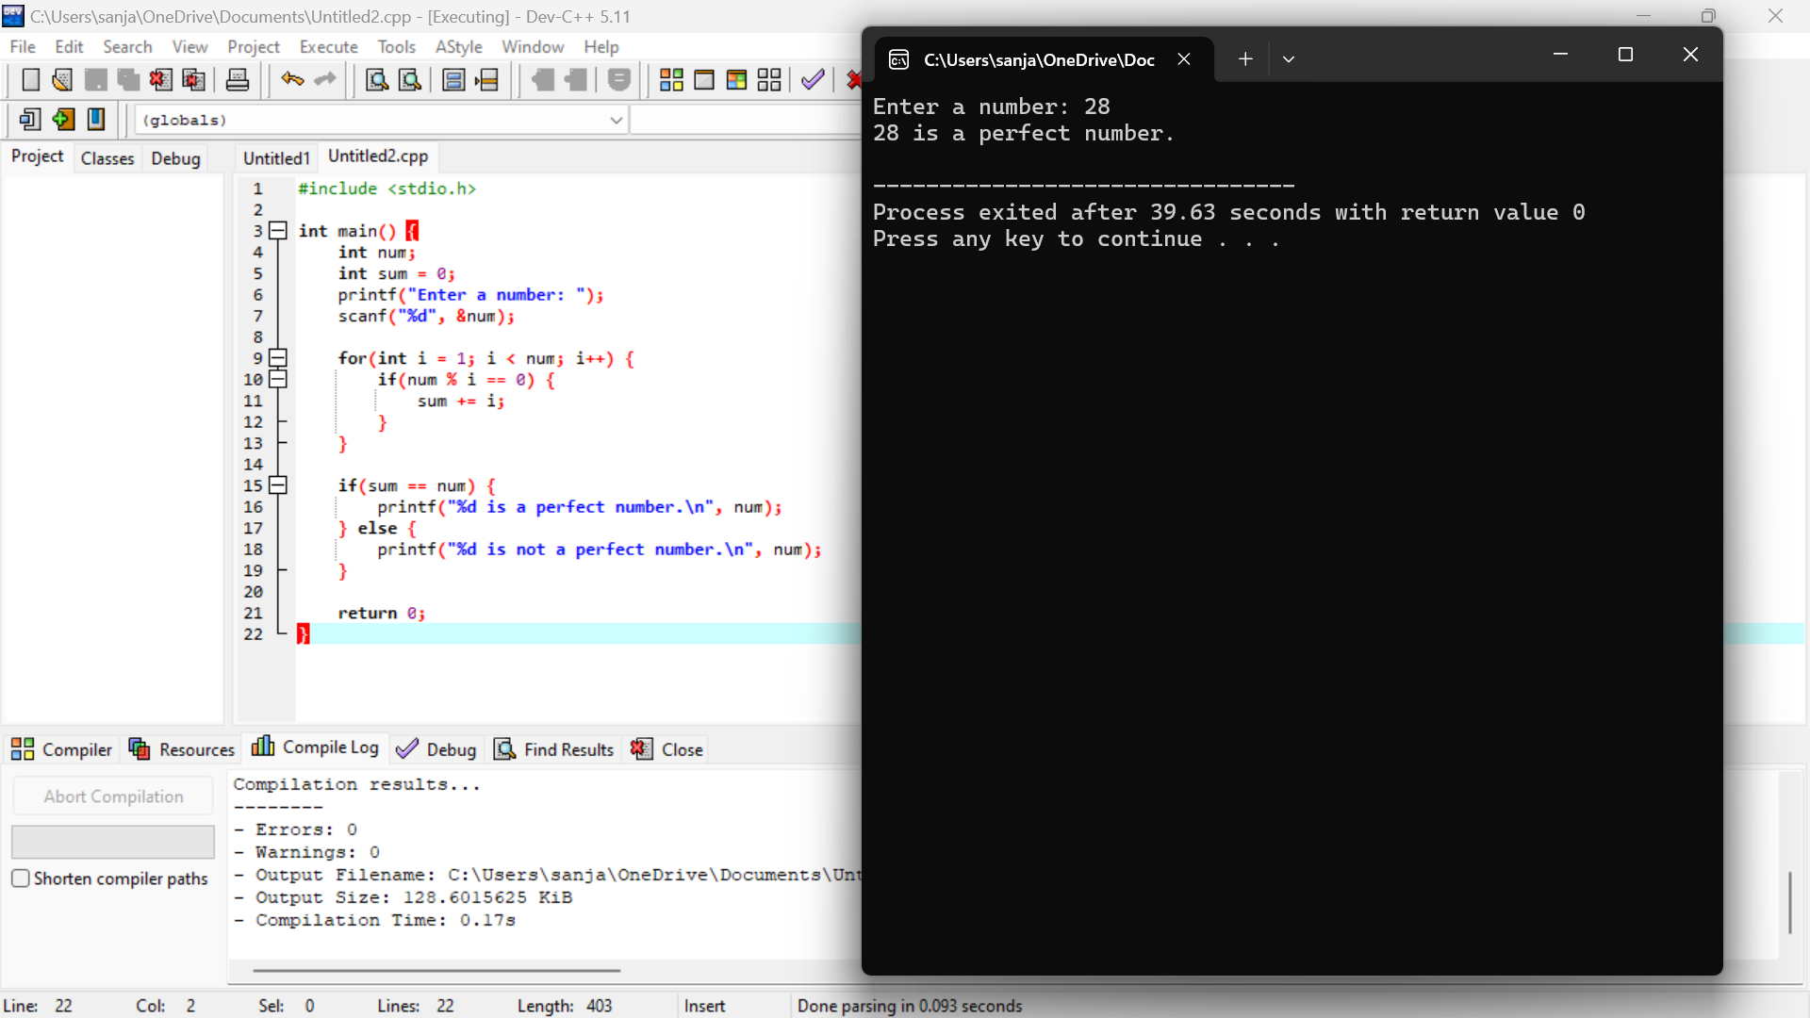

2. DYNAMIC PROGRAMMING

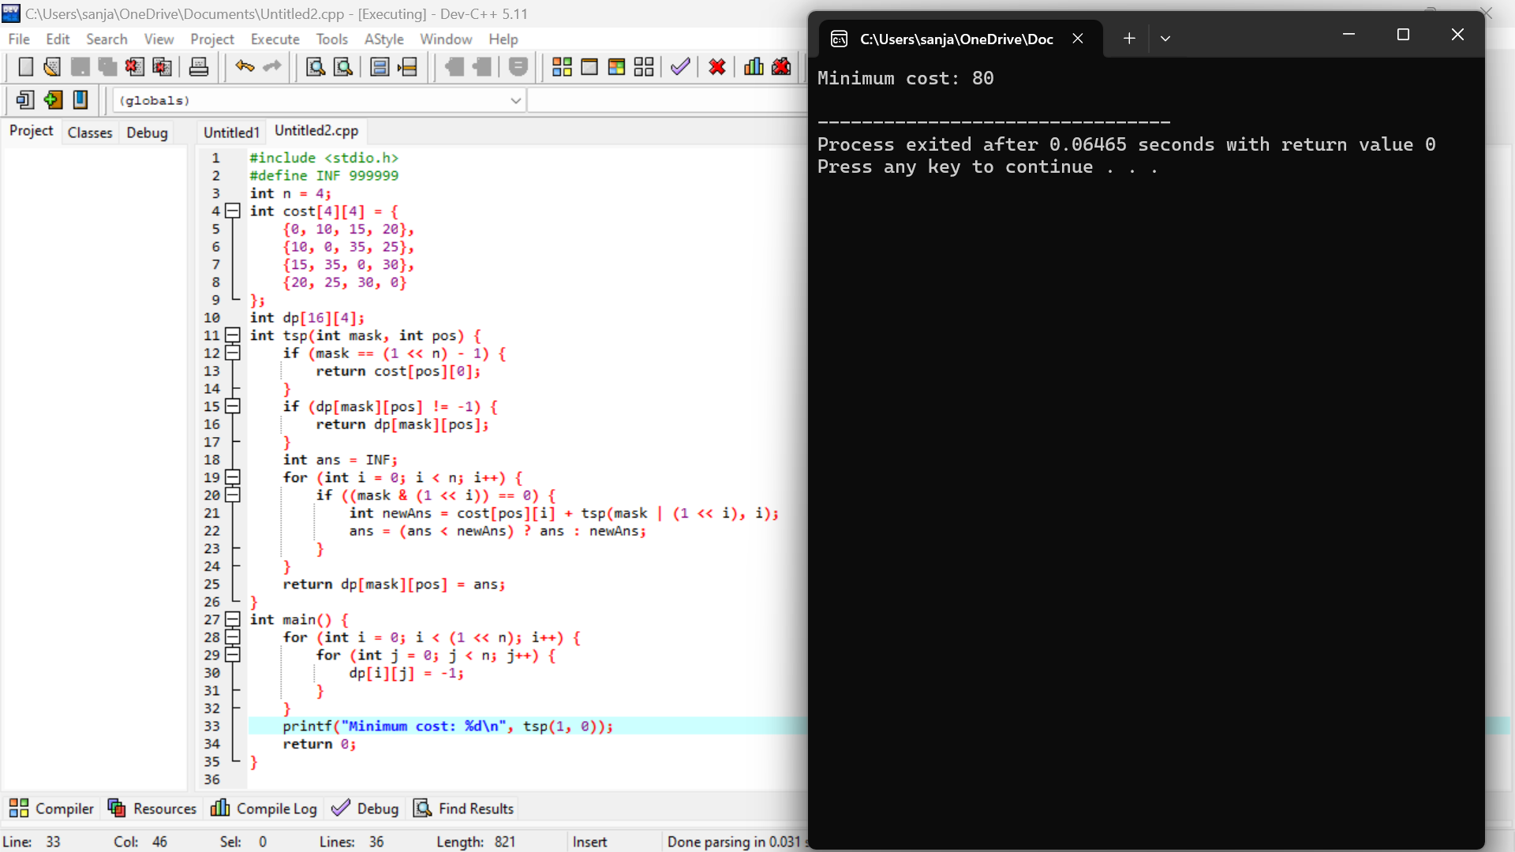

3.Write a program for the given pattern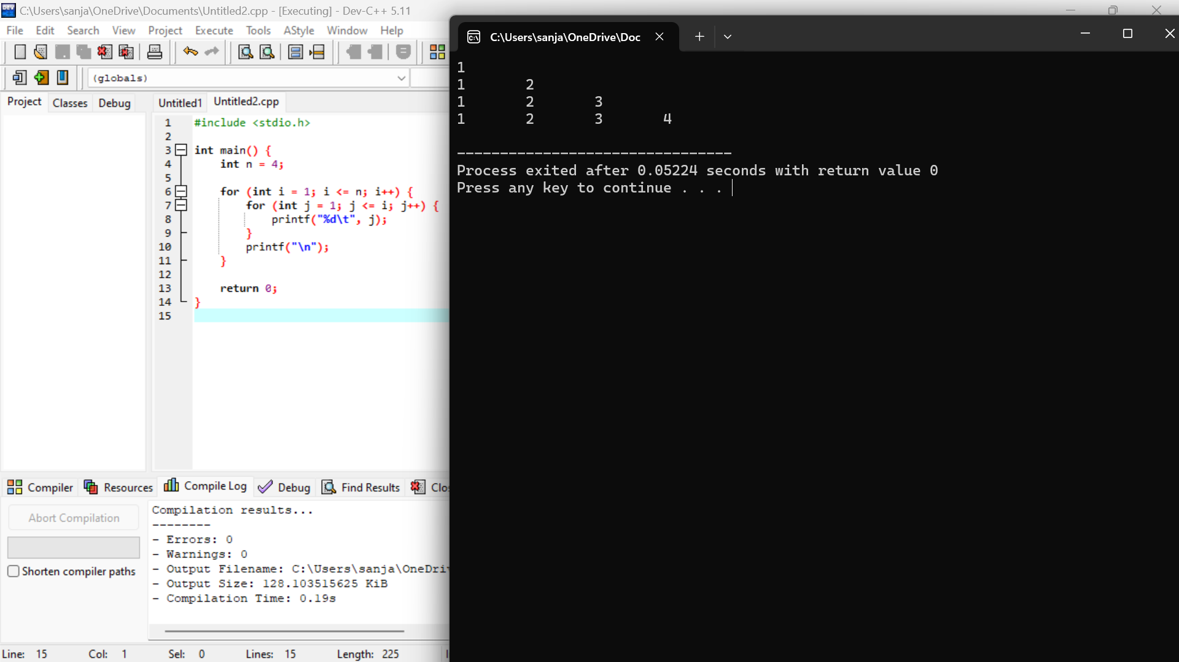

4.PASCAL TRIANGLE

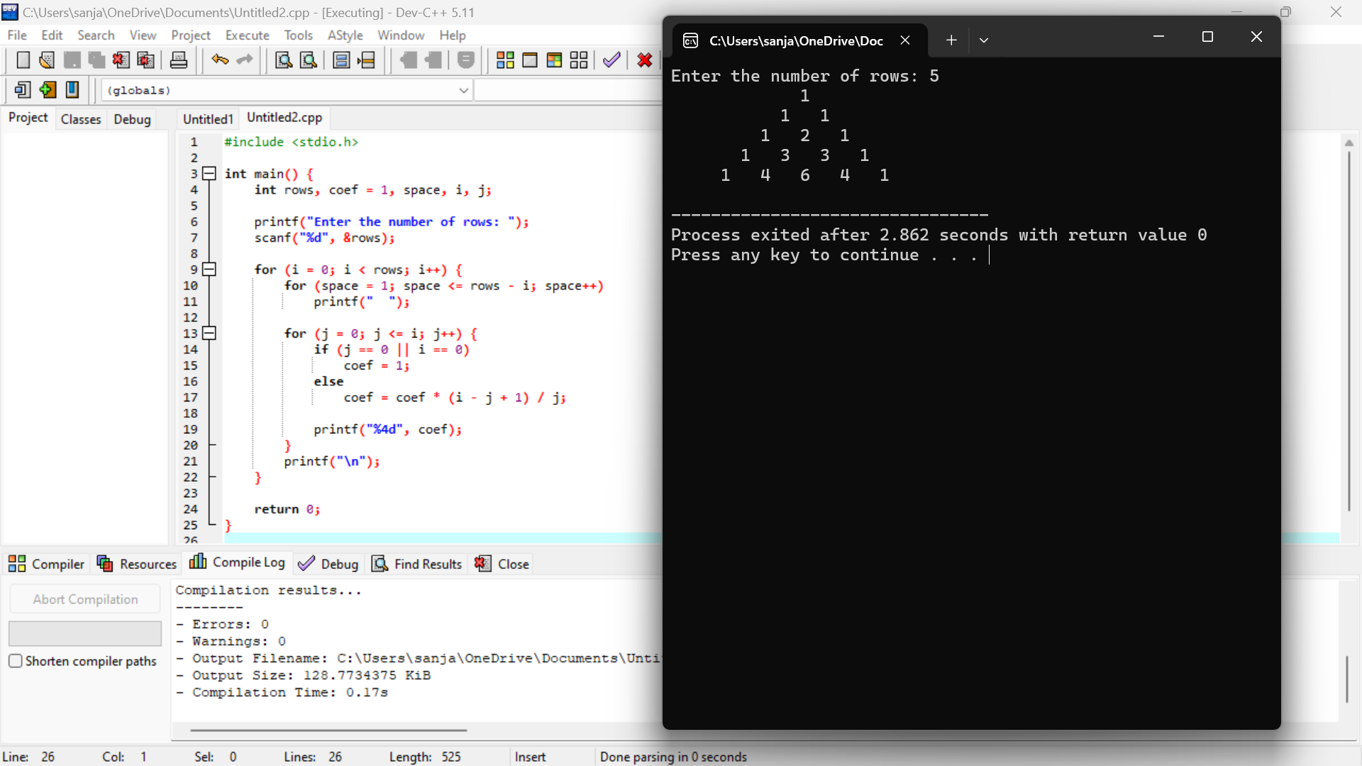

5.SUM OF DIGITS

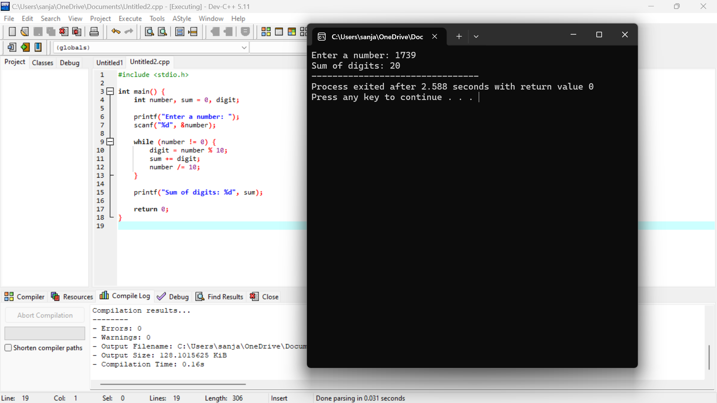

6.MAXIMUM AND MINIMUM NUMBER ON A LIST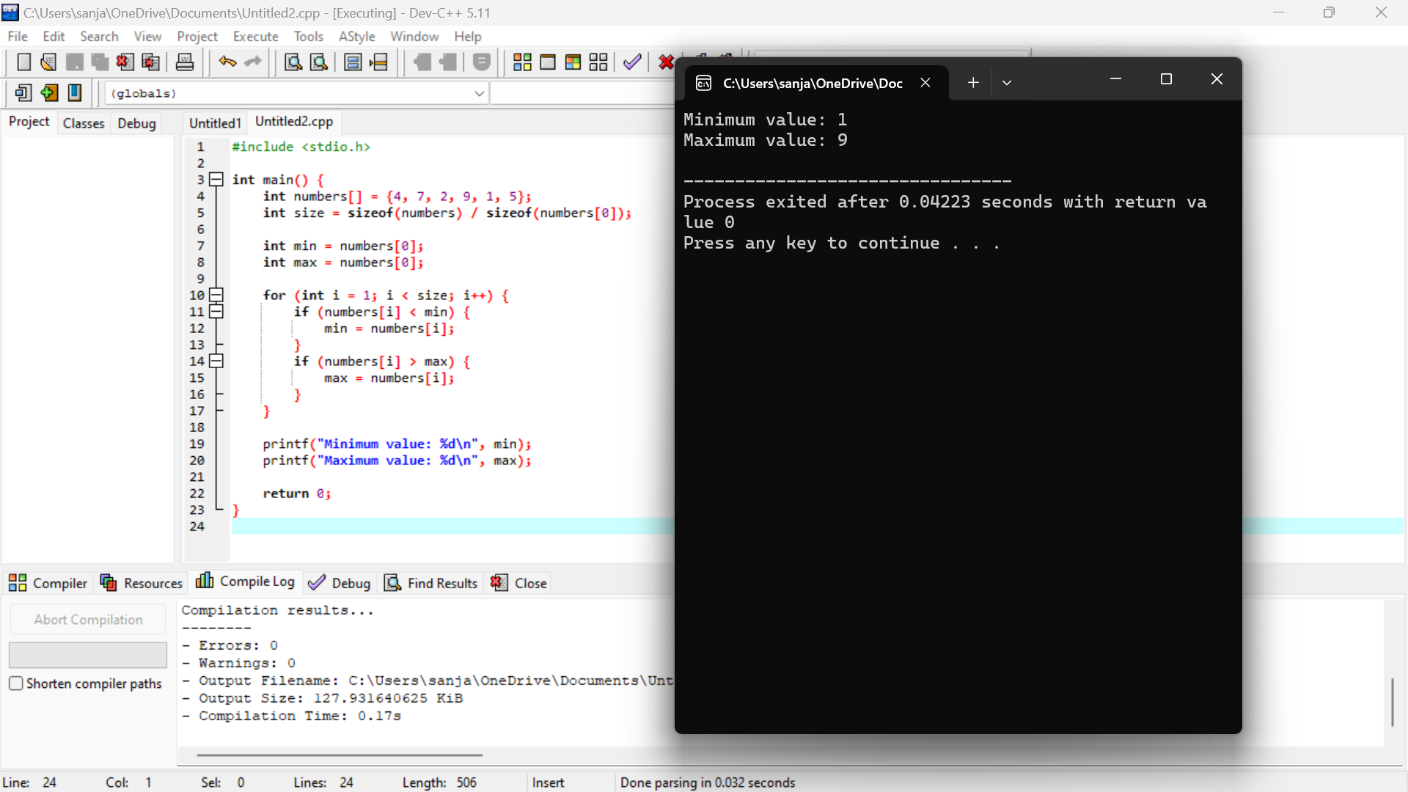

7. Write a program to inset a number in a list.

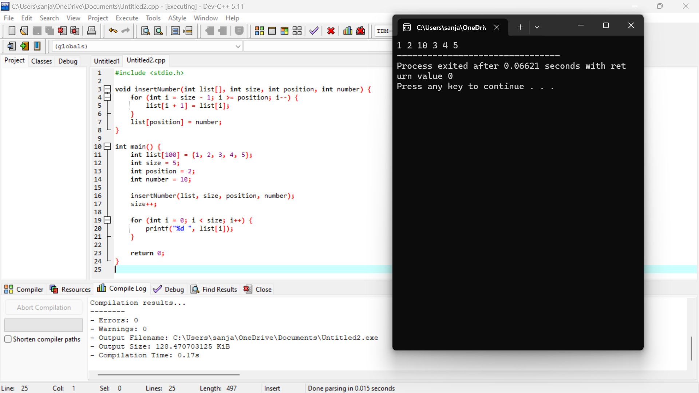

8. Write a program to generate the list of all factor for n value.

